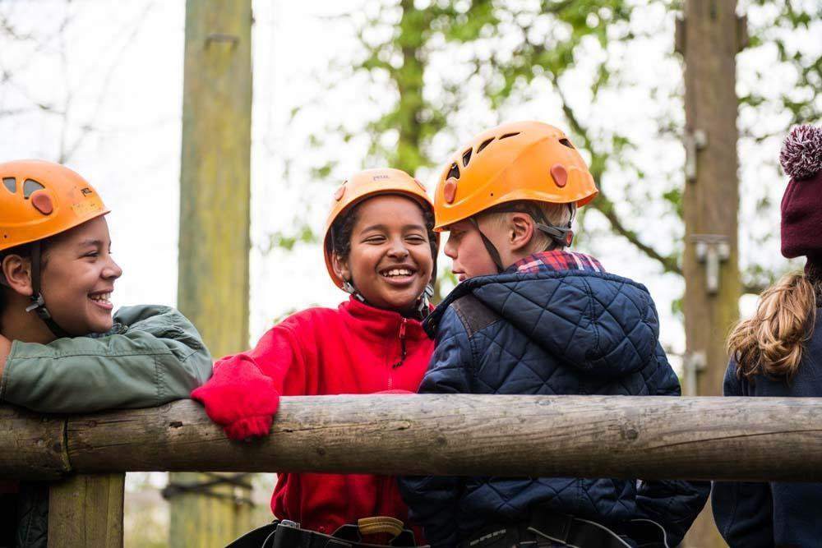
Walking Home Alone Policy
Policy on Unaccompanied Travel to and from Scout Meetings (Cub Scouts — age 8–10½)

Petersham and Ham Sea Scouts
#SkillsForLife


Table of Contents
Table of Contents 2
1. General Principle 3
2. Exceptions — Walking Home Unaccompanied 3
Conditions for Unaccompanied Travel 3
3. Agreement and Consent Form 3
Document Version & Status 4

This document outlines the policy of Petersham & Ham Sea Scouts regarding Cub Scouts travelling to and from meetings and activities unsupervised. The primary responsibility for getting your child safely to and from our meeting place lies with parents and guardians. This policy is based on guidance from the Scout Association and the NSPCC to ensure the safety and well-being of all young people.

1. General Principle
All Cub Scouts must generally be dropped off and collected by a parent or a responsible adult (over the age of 18) nominated by the parent/guardian.
Leaders will stay with any young person who is not collected on time until a parent/guardian arrives.

2. Exceptions — Walking Home Unaccompanied
We recognise that as Cub Scouts get older, some parents may wish to grant permission for their child to travel home alone (e.g. if they live very close by). This is only permitted with explicit, written parental consent and when the parent/guardian has assessed the risks involved.

Conditions for Unaccompanied Travel
- The parent/guardian must inform the Section Leader in writing (using the slip below) that they grant permission.
- The parent/guardian must ensure the child is mature and confident enough to handle the journey safely.
- The parent/guardian must consider factors such as:
— The distance and safety of the route (e.g. road crossings, lighting).
— The time of day / darkness (especially in winter months).
— Whether a responsible adult will be home when the child arrives.
- Parents must immediately notify the Section Leader of any changes to this arrangement.
- The Scout Association and its leaders accept no responsibility for the young person once they have left the meeting place premises unsupervised.

3. Agreement and Consent Form
Please complete and return the slip below to the Section Leader if you wish to grant permission for your Cub Scout to travel home unaccompanied.

To: [Section Leader's Name]
From: [Parent/Guardian Name]

I have read and understood the group's policy regarding unaccompanied travel for Cub Scouts.
I give permission for my child, ____________________________________ [Child's Full Name], to walk home unsupervised from regular Scout meetings held at [Meeting Place Address].
I have assessed the risks associated with the route and my child's maturity, and I am satisfied they can make the journey safely. I will inform the Section Leader immediately if these arrangements change. I understand that the Scout Group's responsibility for my child ends once they leave the meeting place.

Signed: ___________________________
Date: ___________________________
Emergency Contact Number for this arrangement: ___________________________

Document Version & Status
Date | Version | Notes & Who Responsible
03/05/2026 | Issue 1 | Templated by Chilli — content unchanged from source

